 

Week 2: ACF Lab 3: Introduction to EC2

Jan 13, 2024

Do Duy Hung

Student ID: 104182779

1, Choose Start Lab in the crossbar and wait for the circle icon to the right of the AWS link in the upper-left corner turns green. It takes about 2-3 minutes.

2, And if you want to connect to the AWS Management Console, click on the green button link.

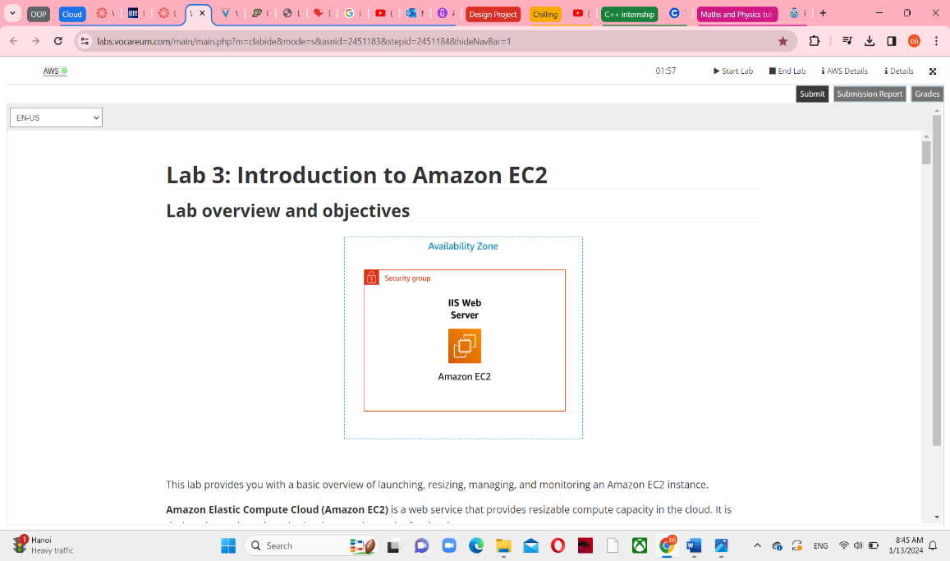

**Task 1: Launch Your Amazon EC2 Instance**

4, In this website, choose Services -> Compute -> EC2

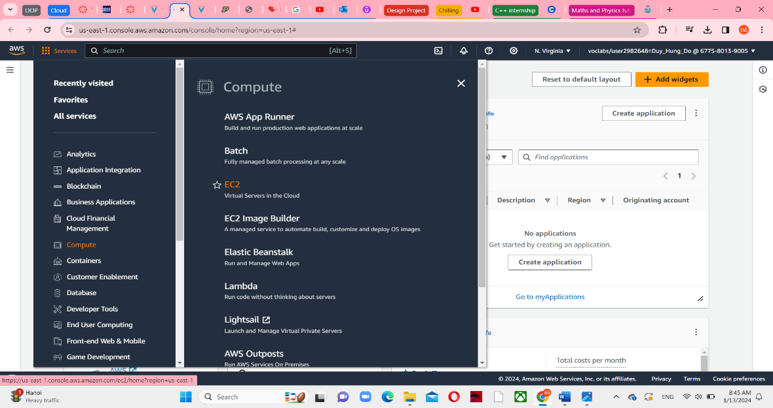

5, Select Launch instance to see some settings.

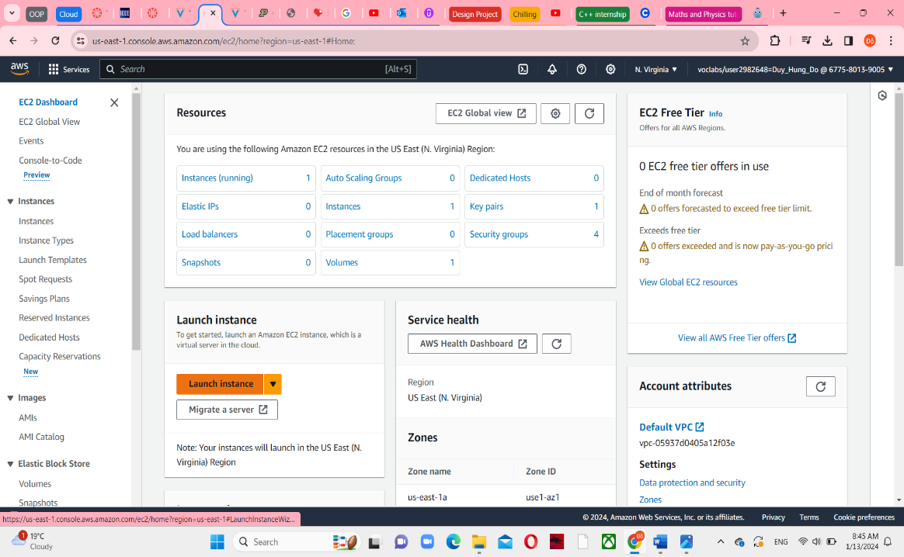

**Step 1: Name and tags**

6, Fill the Name’s blank with the text “Web Server”

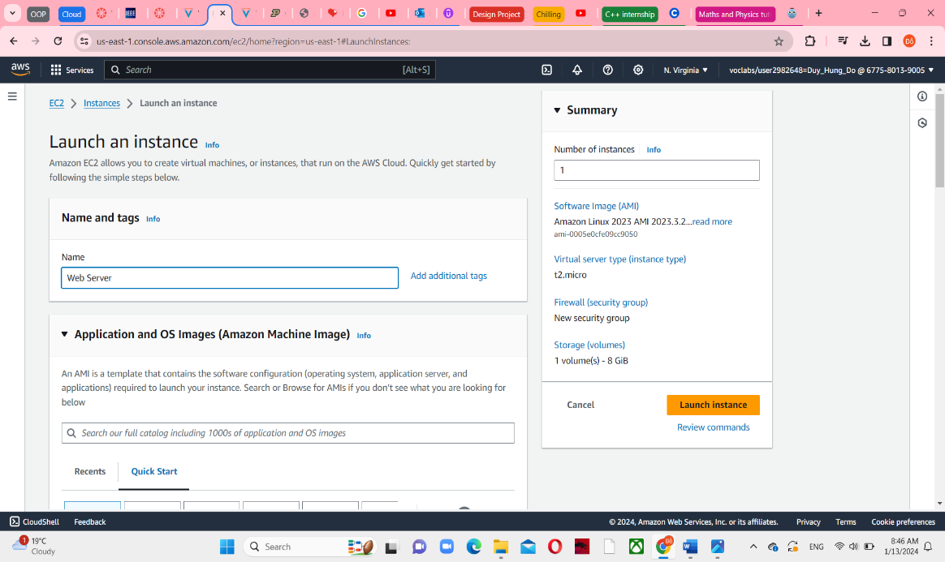

**Step 2: Application and OS Images (Amazon Machine Image)**

7, Keep the default settings in here. Amazon Linux and Amazon Linux 2023 AMI are automatically selected.

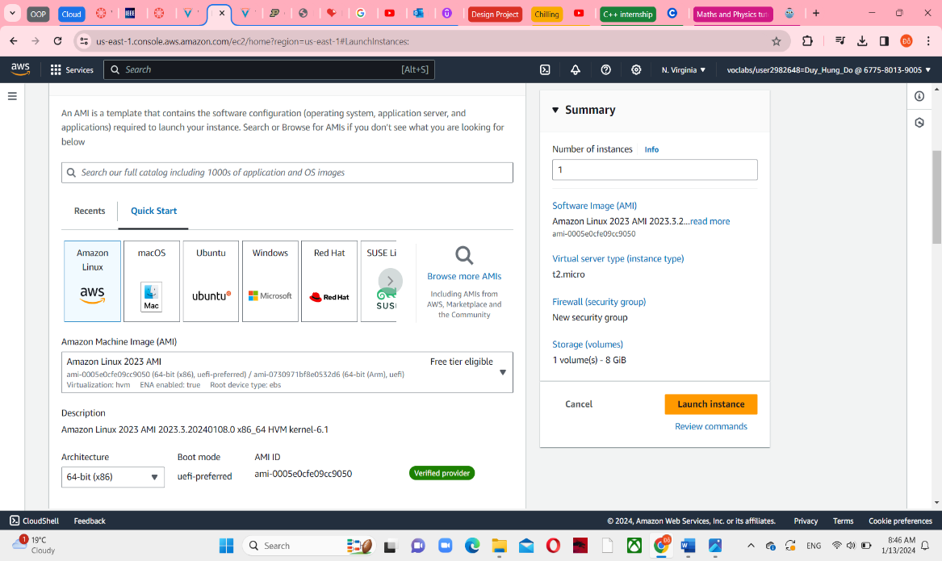

**Step 3: Instance Type**

9, Keep the default t2.micro selected

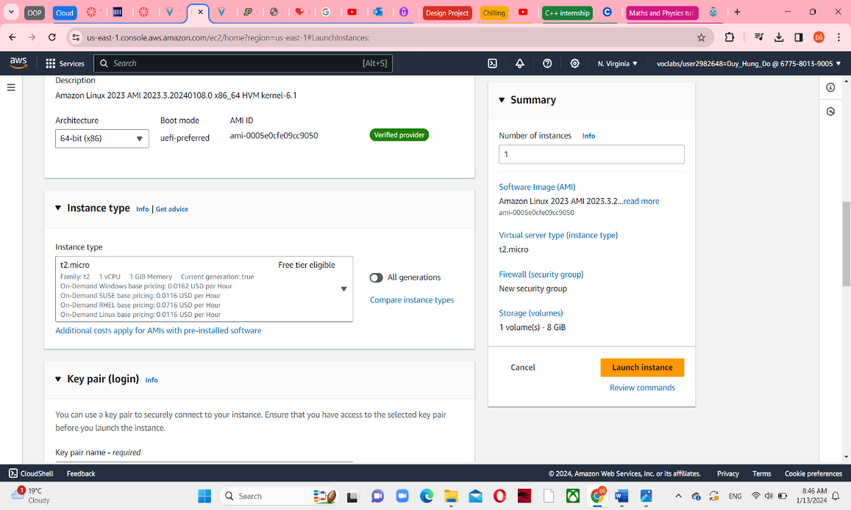

**Step 4: Key pair (login)**

10, In the Key pair name – required blank, choose vockey,

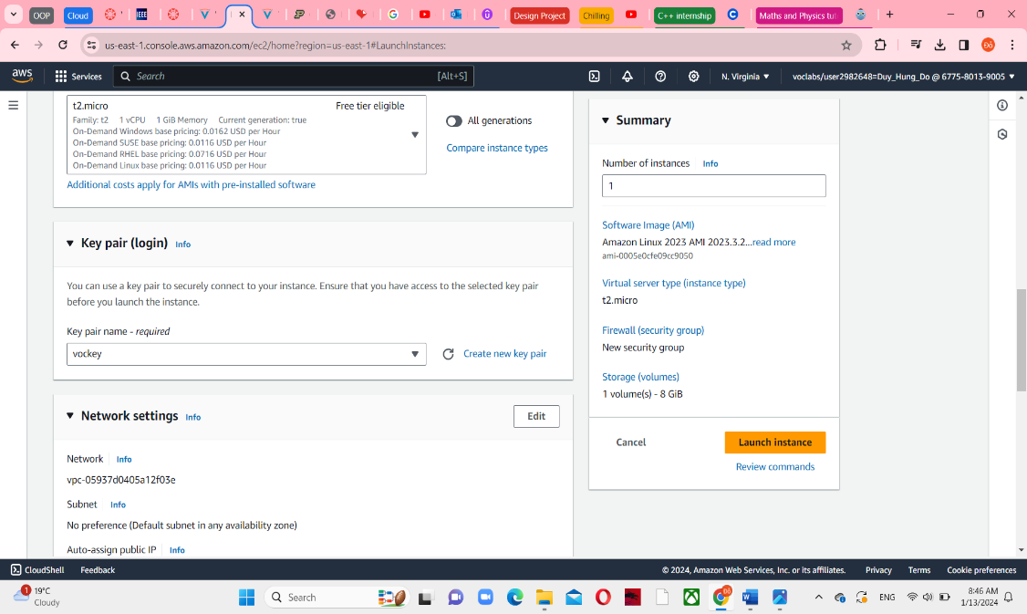

**Step 5: Networks settings**

11, Choose Edit button in the top right

12, In the VPC selection, choose Lab VPC

13, Under Firewall (security groups), choose Create security group and follow this instructure:

* Security group name: Web Server security group
* Description: Security group for my web server

! If one rule exists, choose Remove in the right bottom.

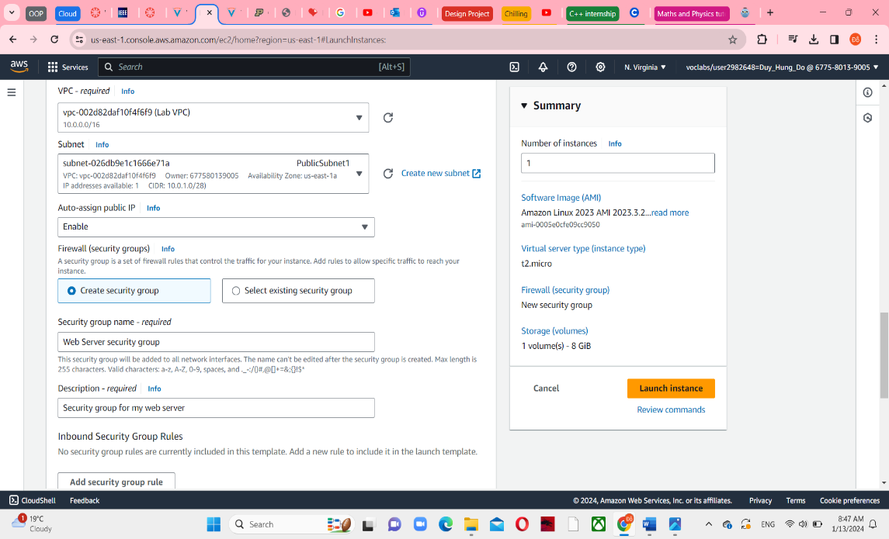

**Step 6: Configure storage**

14, Keep the default settings in here. Using 8 GiB disk volume is automatically selected

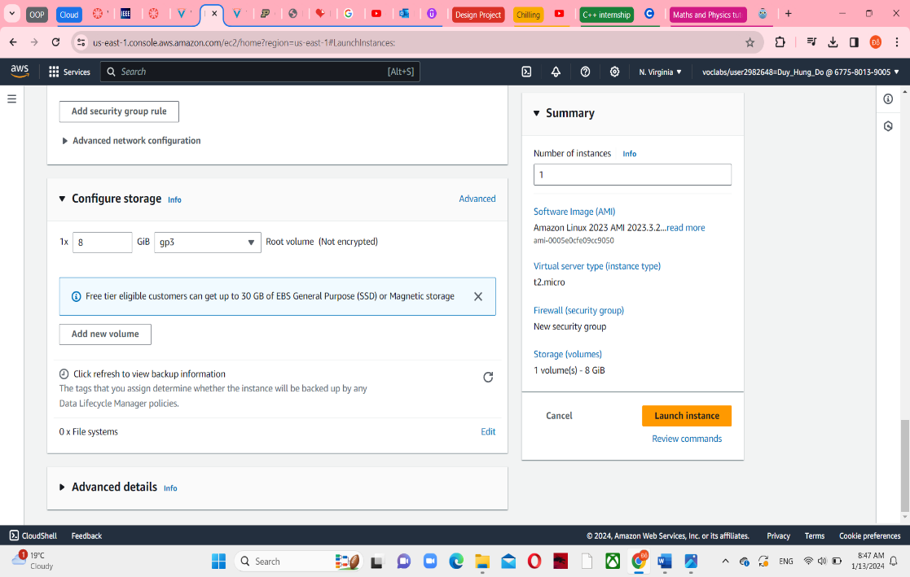

**Step 7: Advanced details**

16, Select Enable for Termination protection’s blank

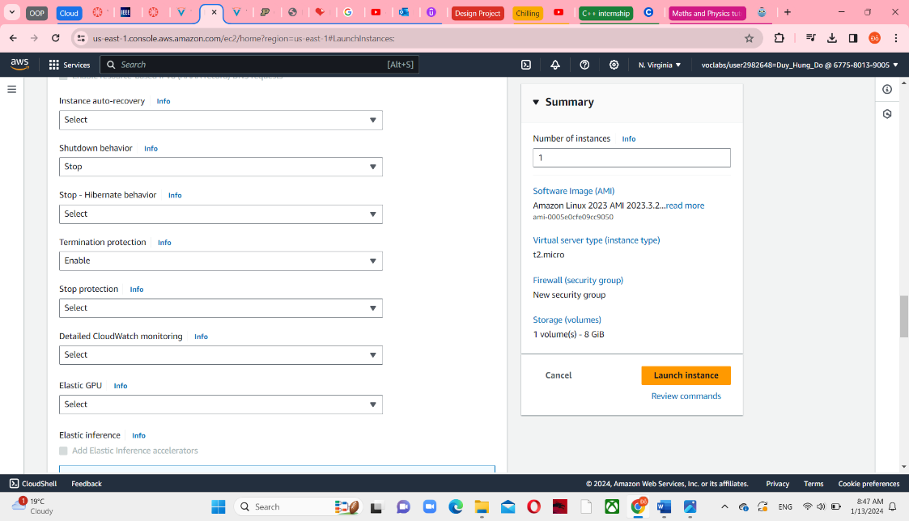

17, Put some code form html to create a web server into the User data box.

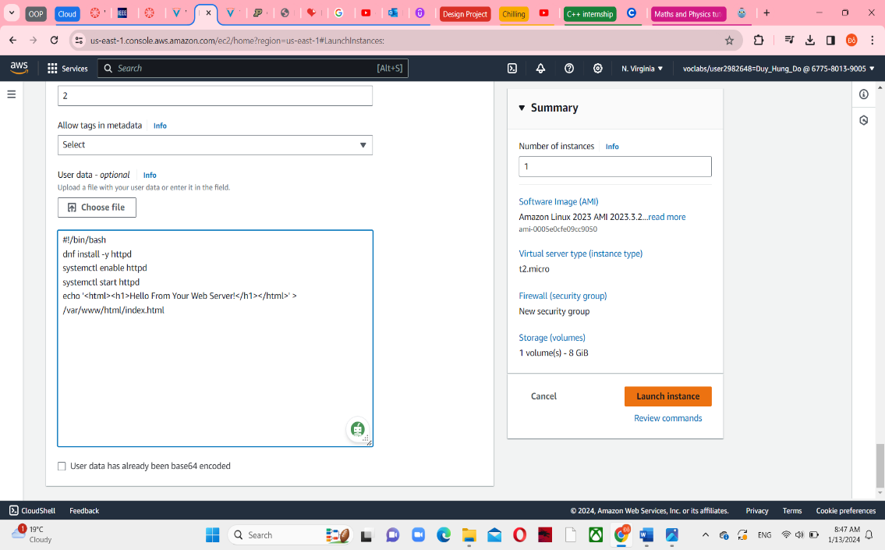

**Step 8; Launch the instance**

18, Choose Launch instance to see a Success message and it saves the information.

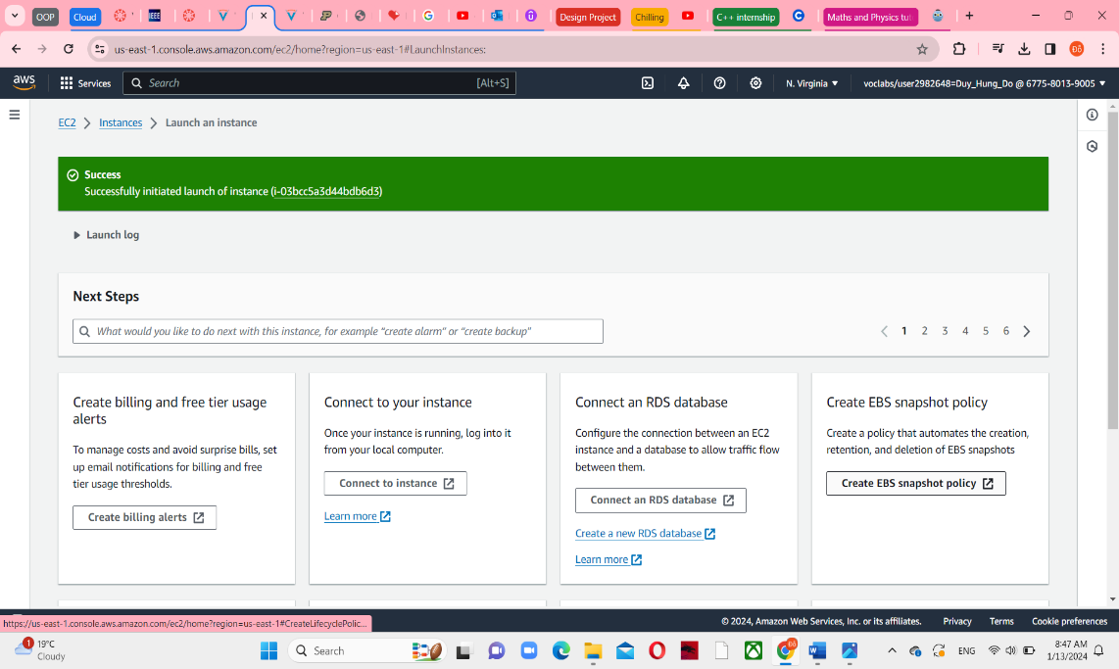

19, Choose View all instances in the bottom right, and then select the checkbox Web Server to view some details tab.

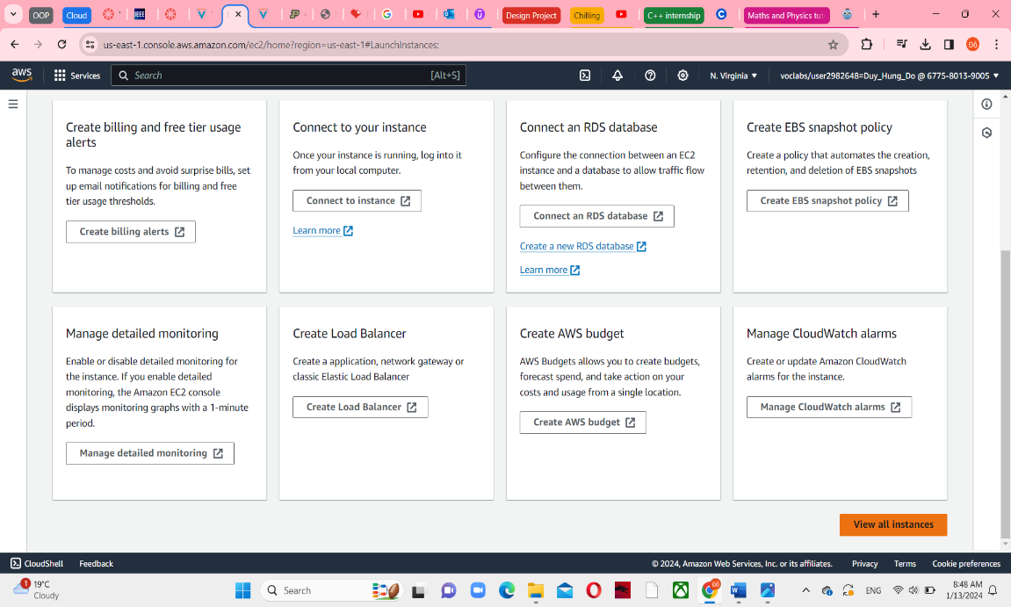

20, Wait for the instance to display the instance state is running and the status checks is 2/2 checks passed. You can reload this page to get the process faster.

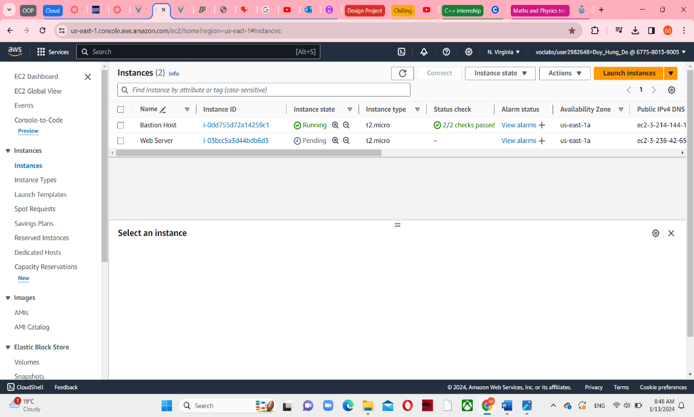

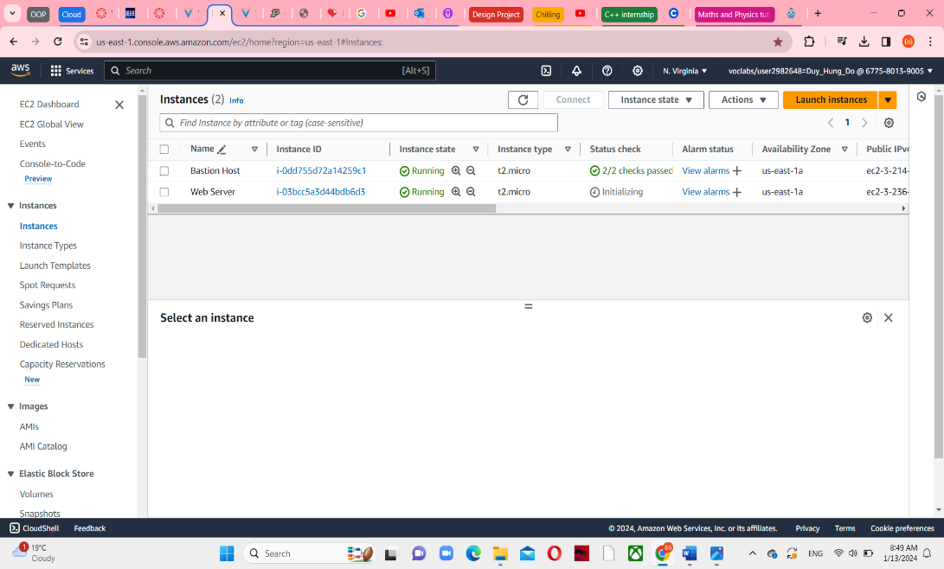

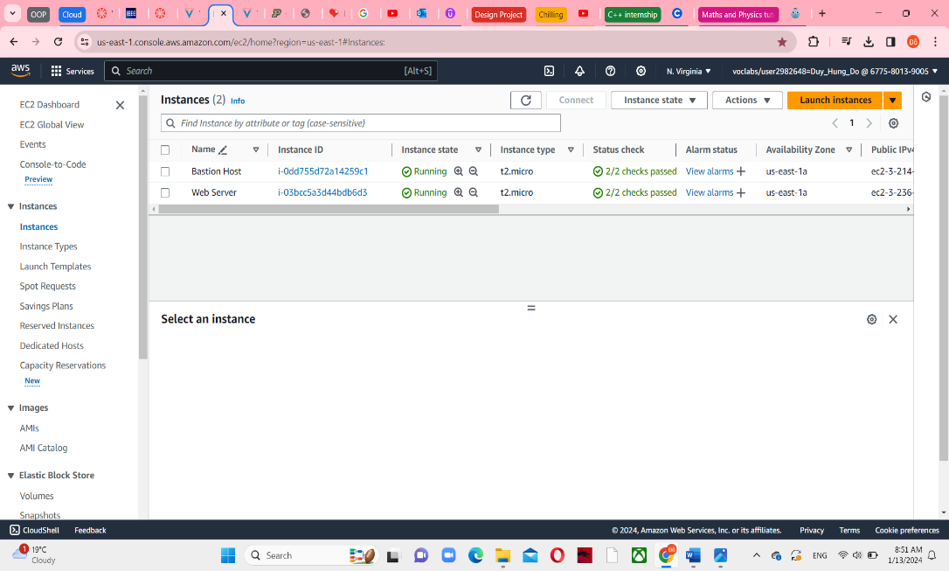

**Task 2: Monitor Your Instance**

21, In the Web Server details, choose Status and alarms tab, and then you can see both system reachability and instance reachability checks have passed.

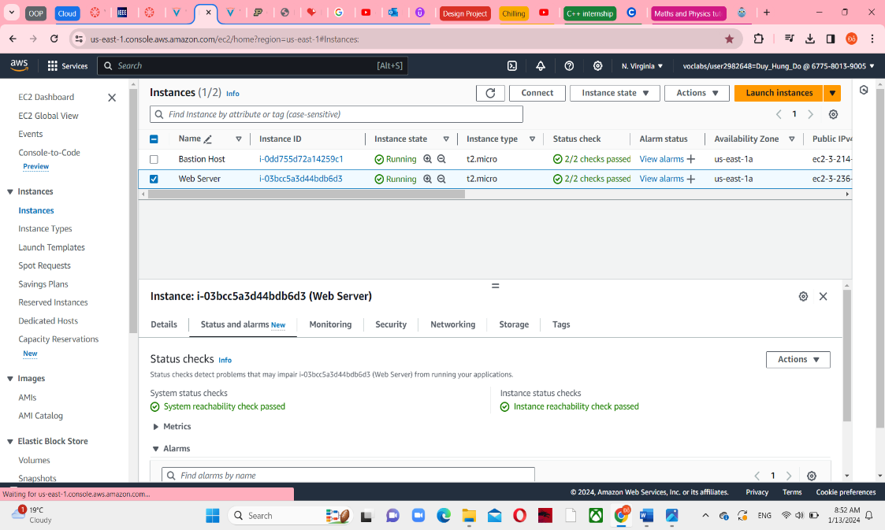

22, In Monitoring tab, you can see some metrics and graphs. And then you can choose the three dots icon in any graph and select Enlarge to see an expanded view of the chosen metric.

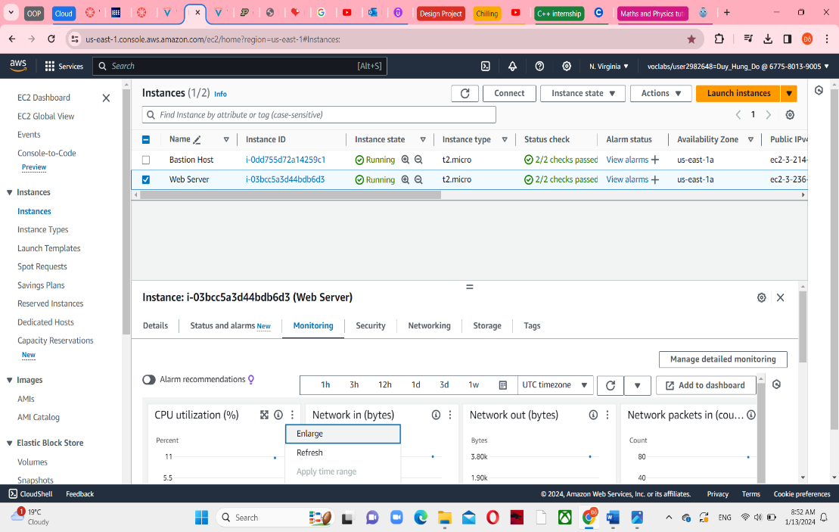

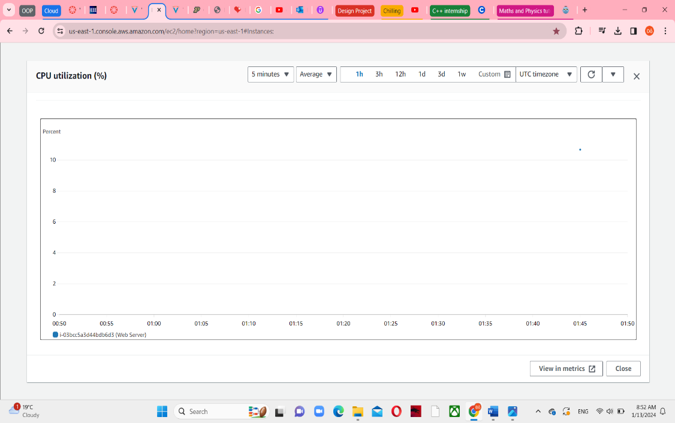

23, Return to EC2 console web, in the Action menu towards the top of the console, select Monitor and troubleshoot -> Get system log.

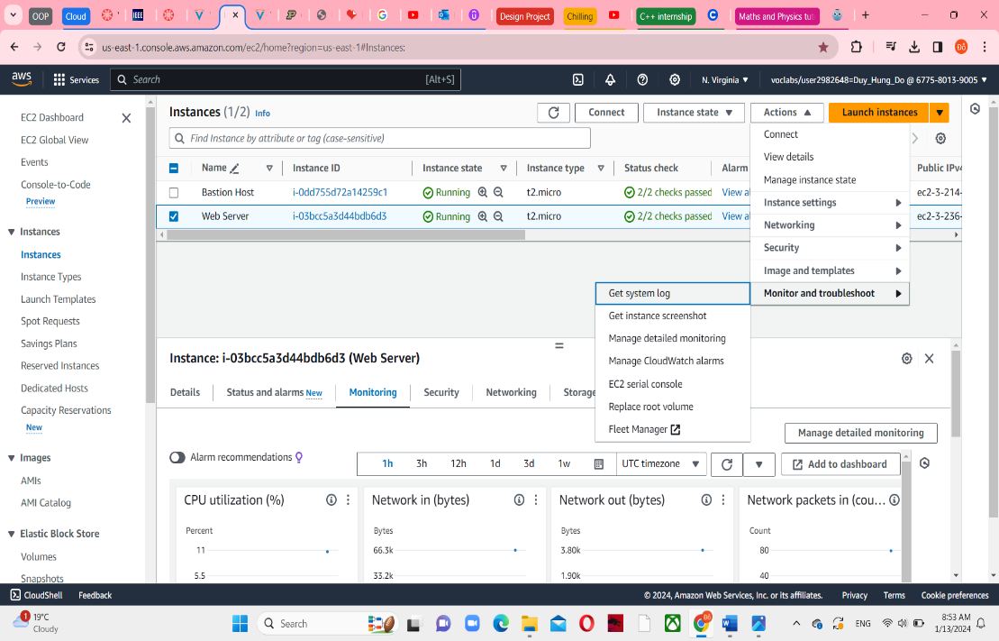

24, You can see the HTTP package was installed form the user data that you added the code. After viewing, choose Cancel to comeback the main website.

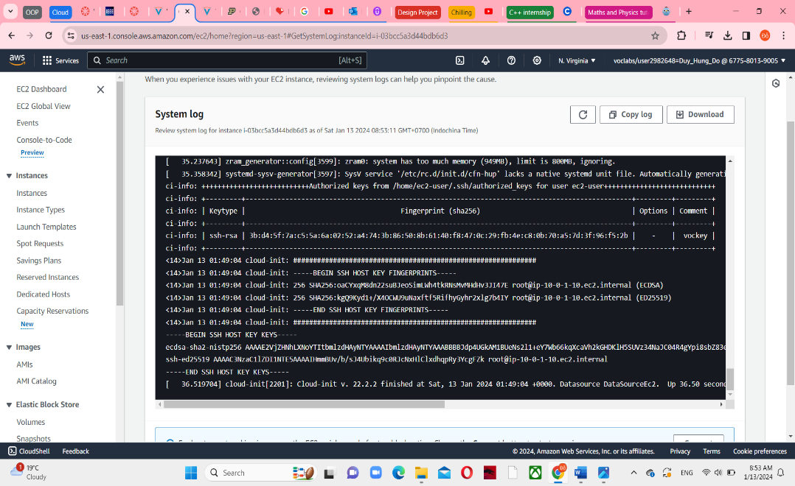

26, Ensure Web Server is still selected, choose the similar to Action menu in previous step, but at the end, choose Get instance screenshot. It shows what your Amazon EC2 instance console would look like if a screen were attached to it. After viewing, select Cancel.

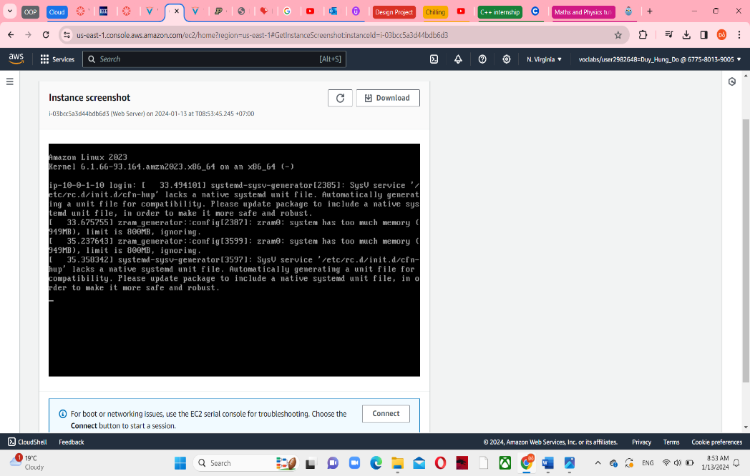

**Task 3: Update the security group and access the web server**

28, Always select the Web Server, choose Details tab and see the public IPv4 address, copy and paste on other tab. You can’t access the web server because you haven’t permitted the inbound traffic on port 80 – HTTP web requests.

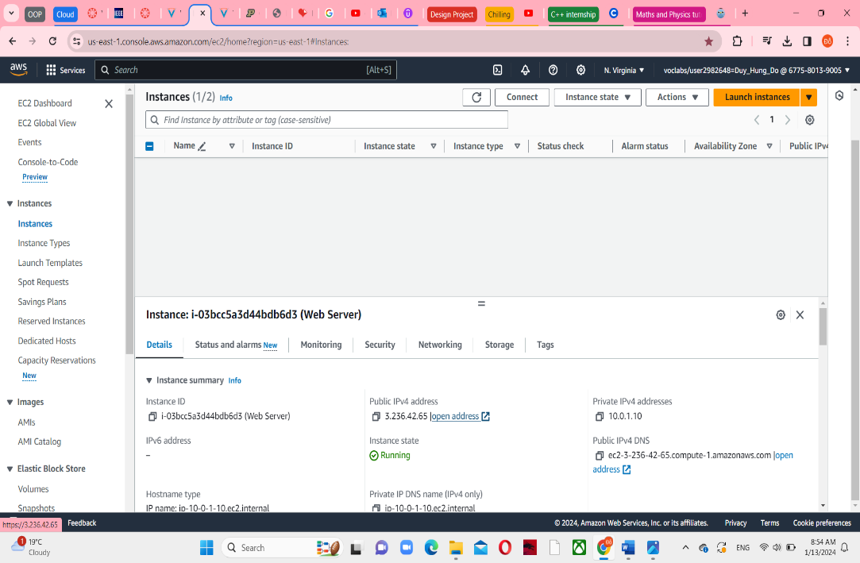

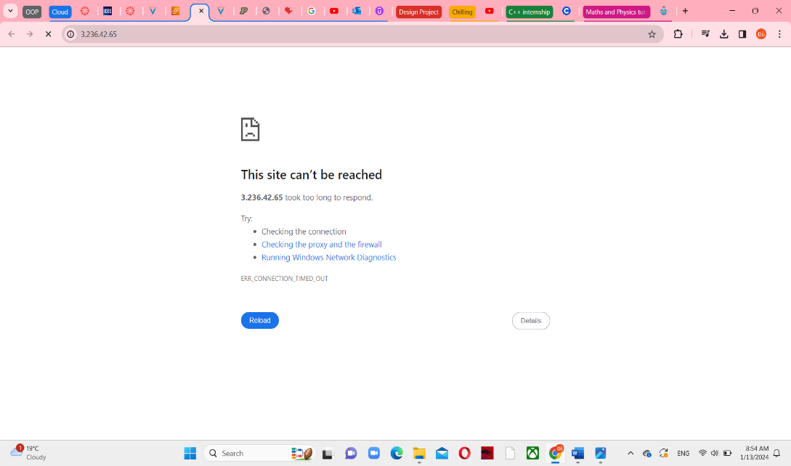

31, Return to the EC2 Console tab, click on the Security Groups in the left navigation pane, select Web Server security Group, you can see Inbound rules tab under -> click on this.

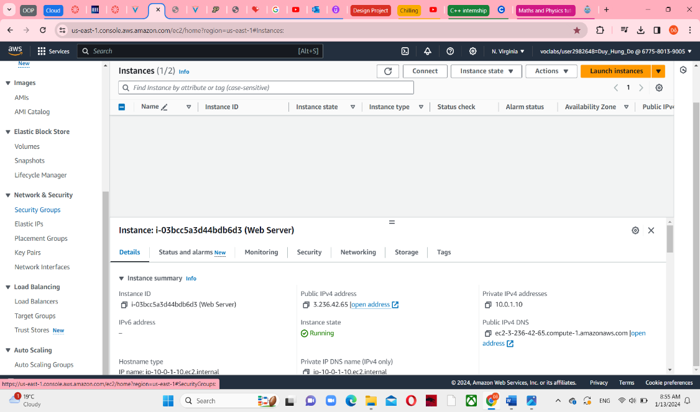

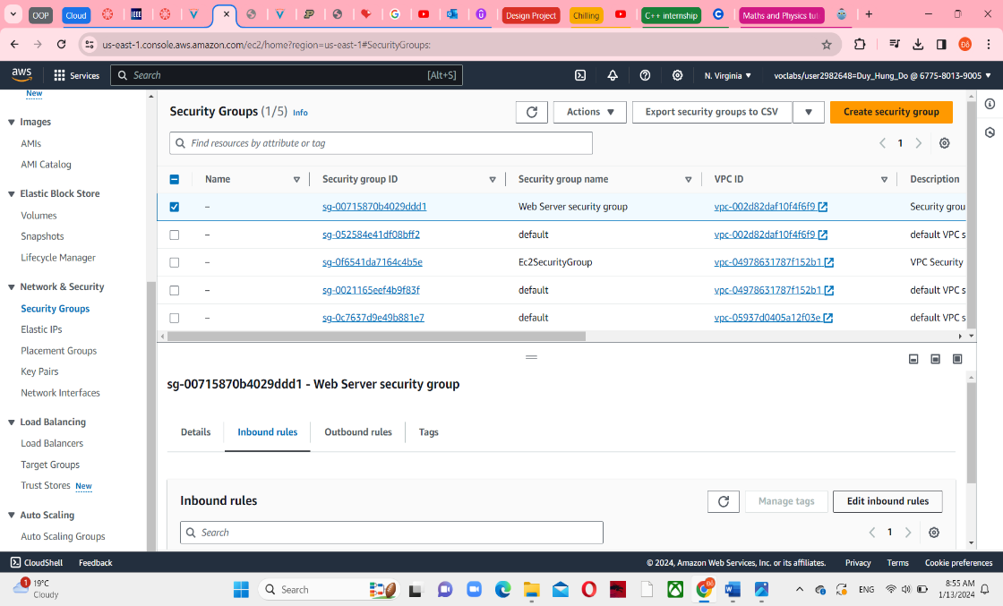

35, Choose Edit Inbound rules and add rule with the type of HTTP and source of Anywhere-IPv4. Save the rules when it has done.

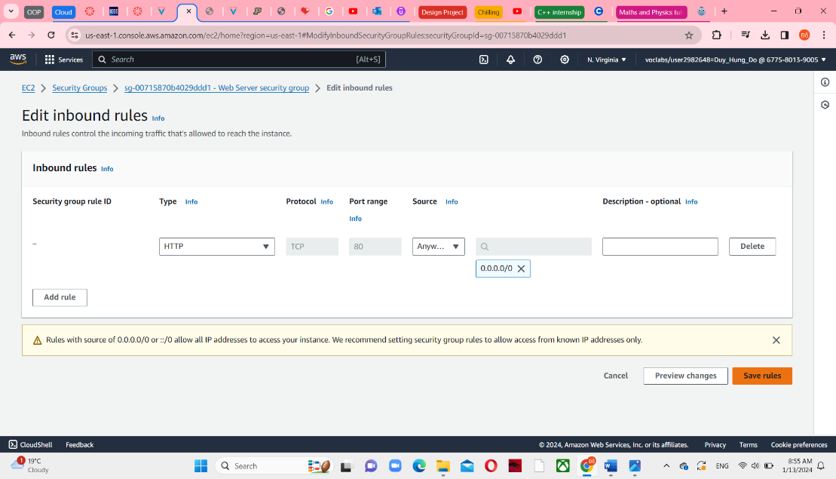

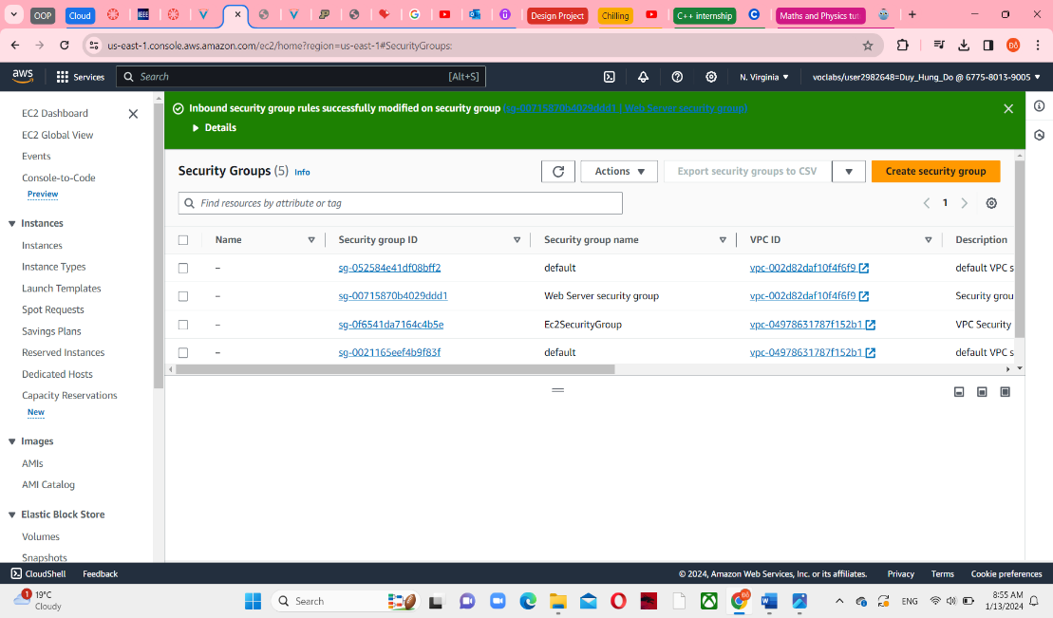

36, Return the web server tab and reload it.

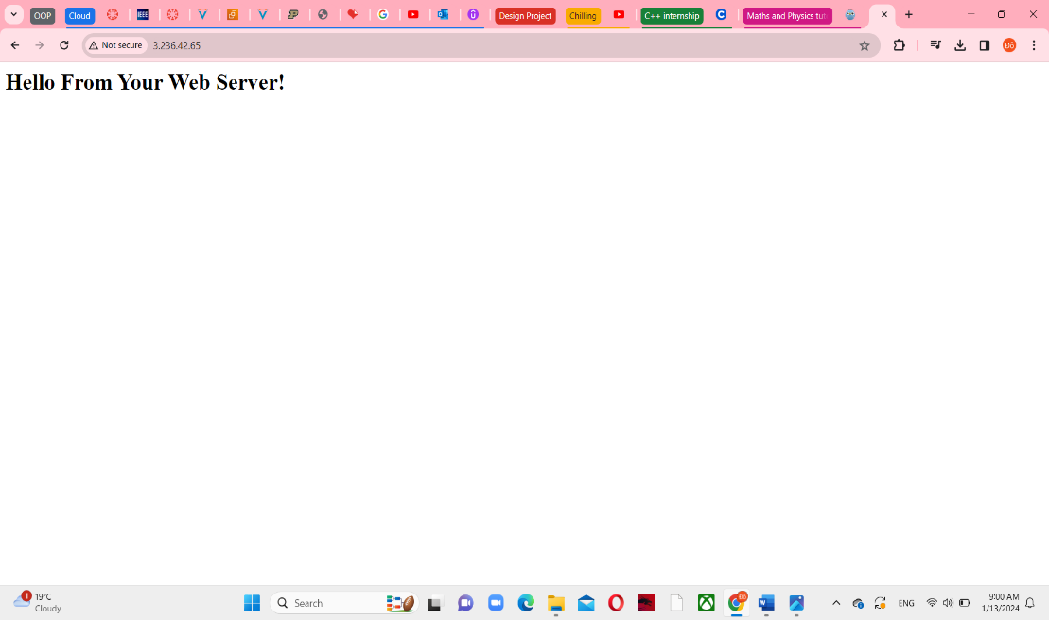

**Task 4: Resize The Instance: Instance Type and EBS Volume**

**Step 1: Stop the Instance**

37, Return to Instances pane and still select Web Server instance. In the Instance state menu, select Stop instance

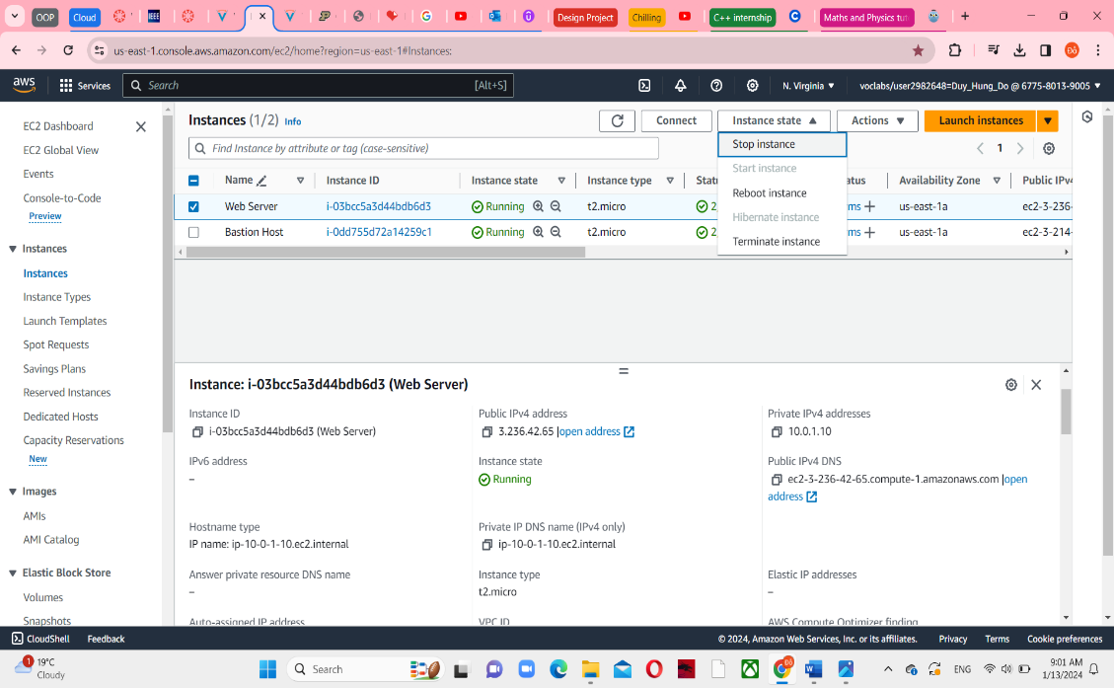

39, Choose Stop and wait for Instance state to display “Stopped”

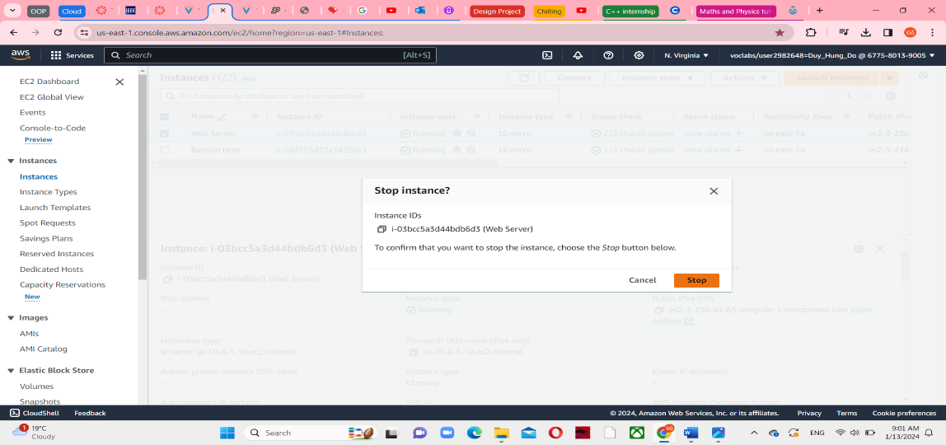

It is stopping

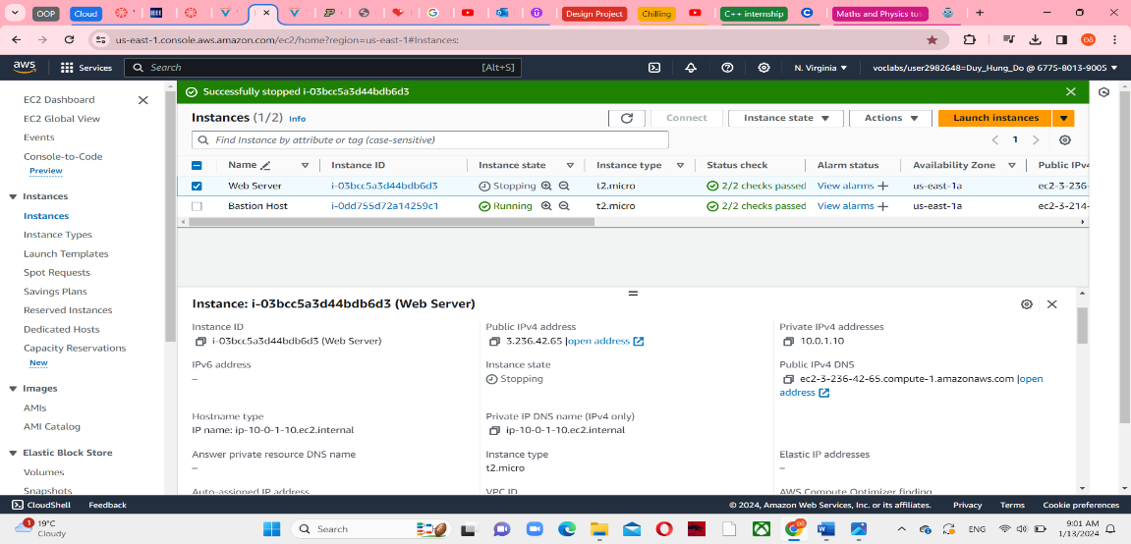

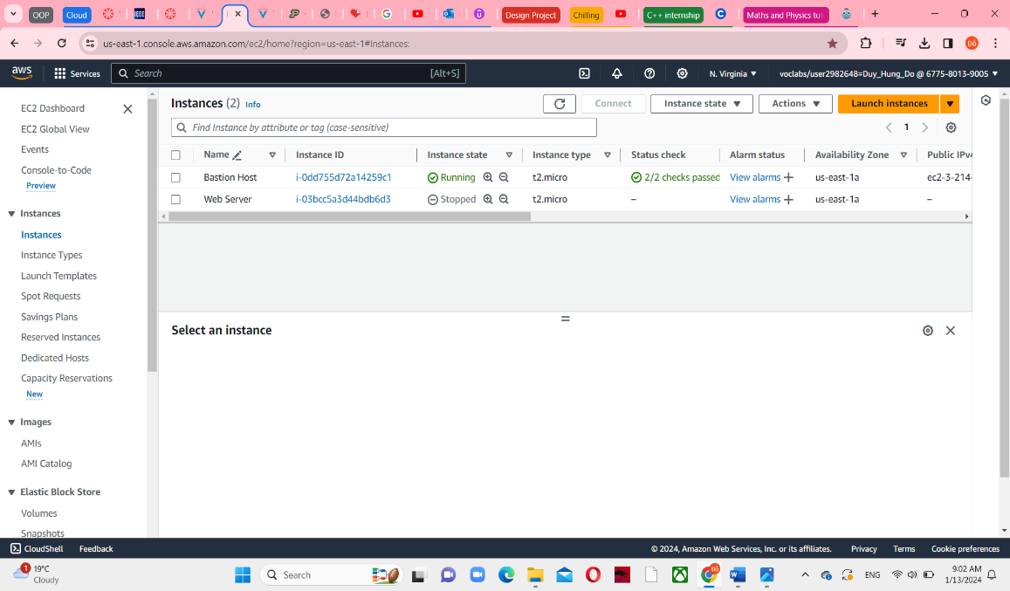

**Step 2: Change the Instance Type and enable stop protection**

41, Choose Actions menu in Web Server instance, select Instance settings -> Change instance type to t2. small

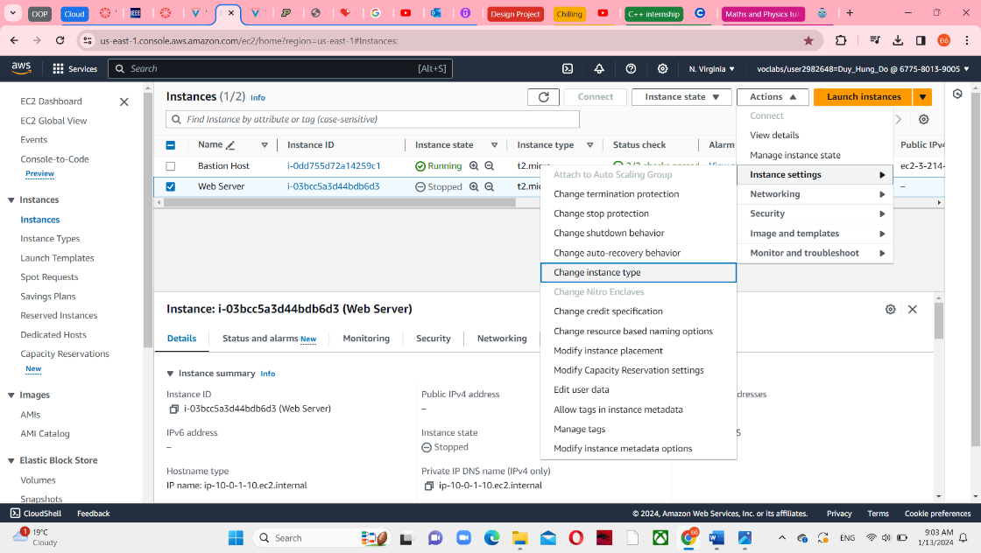

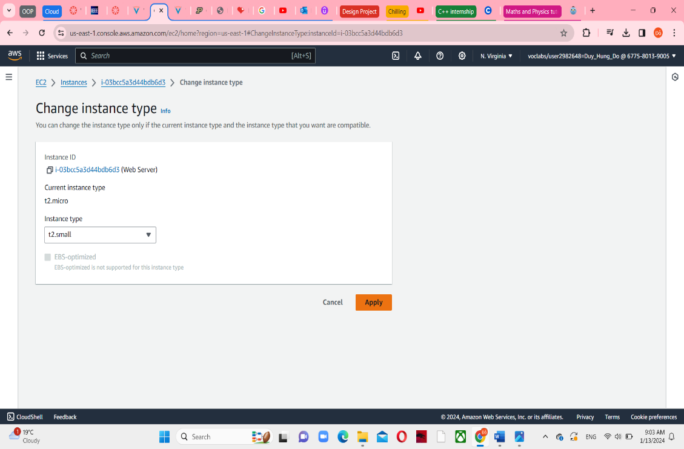

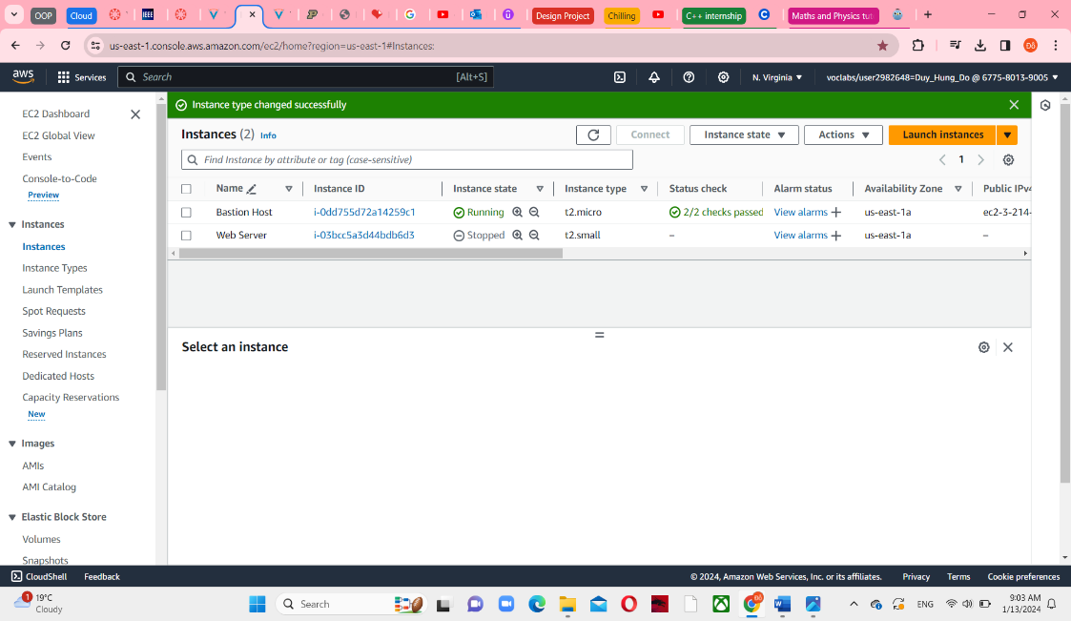

42, Continue with Action menu, select Instance settings -> Change stop protection and enable them.

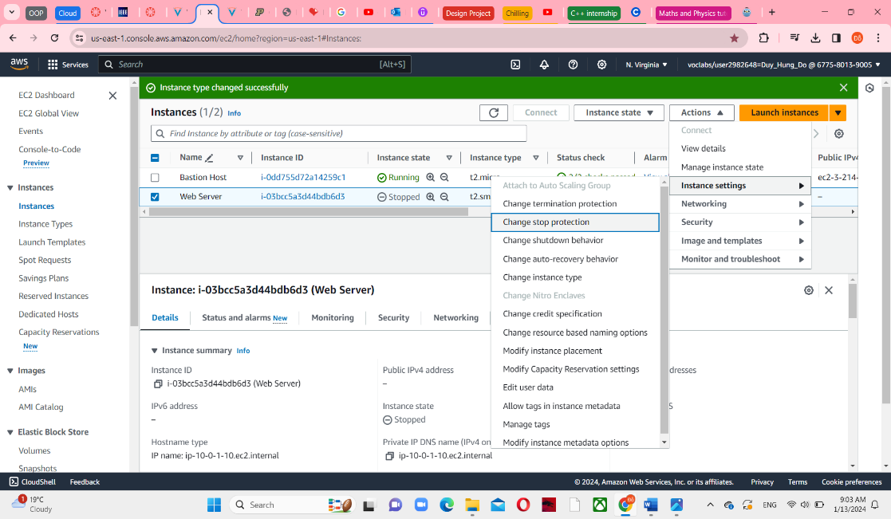

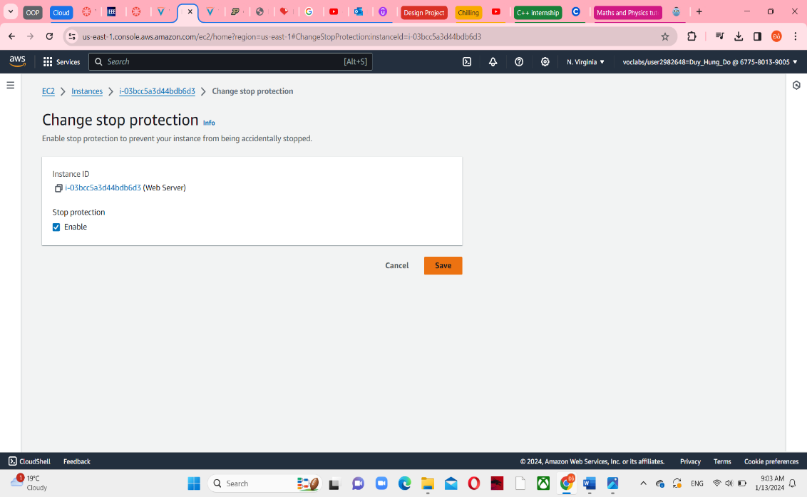

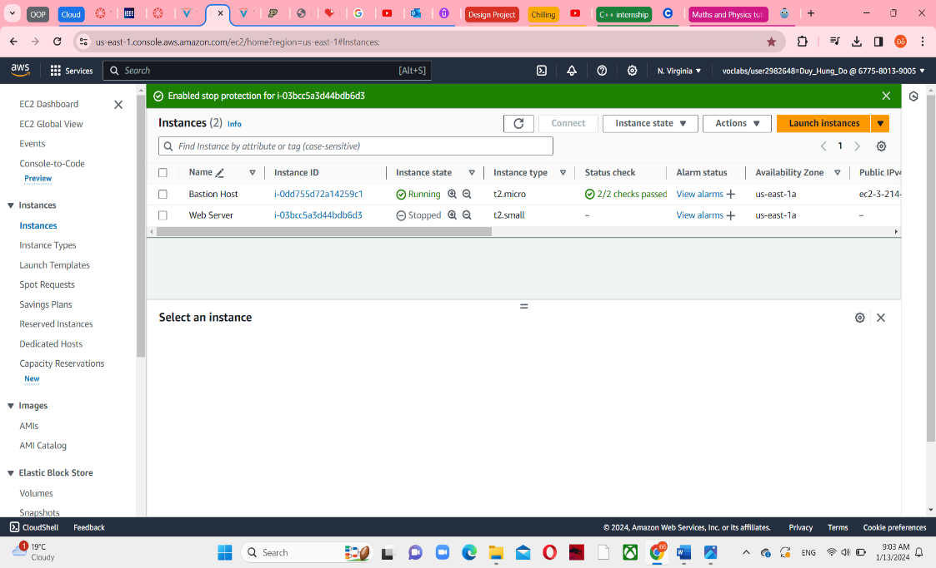

**Step 3: Resize the EBS Volume**

43, In the Web Server instance, choose the Storage tab, and click on the name of the Volume ID

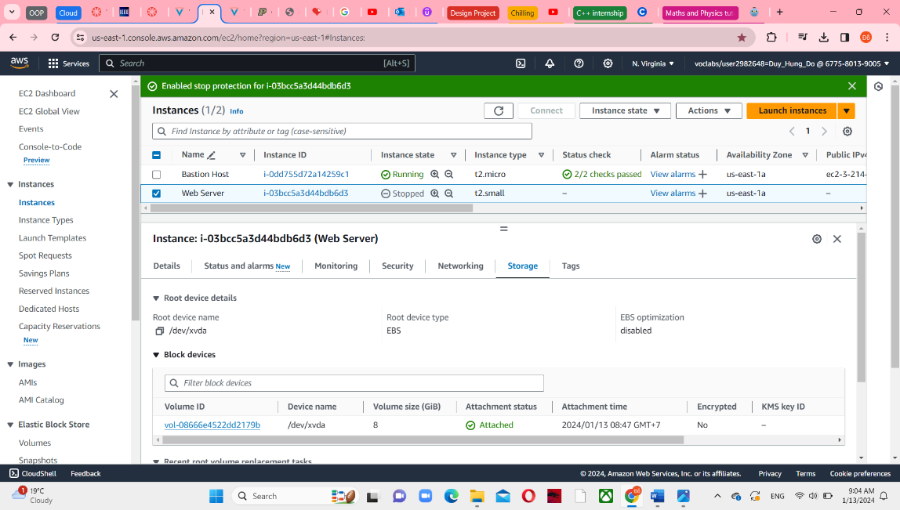

Select the checkbox next to the volume that displays, and in the Actions menu, select Modify volume

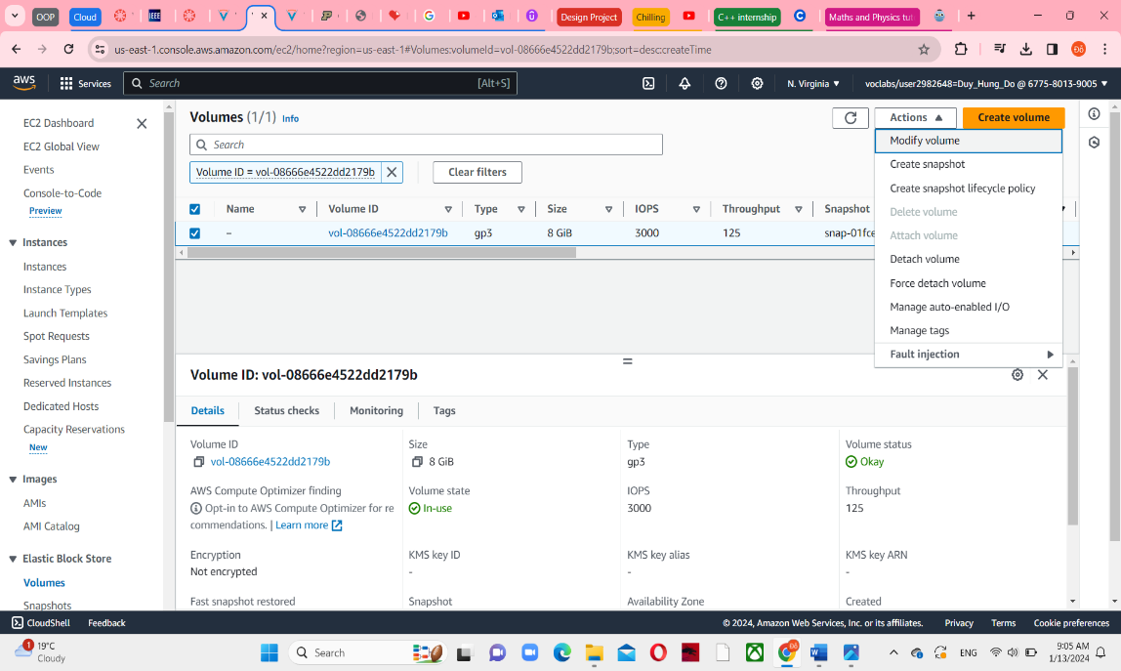

45, Change the size from 8 to 10 GB in this disk

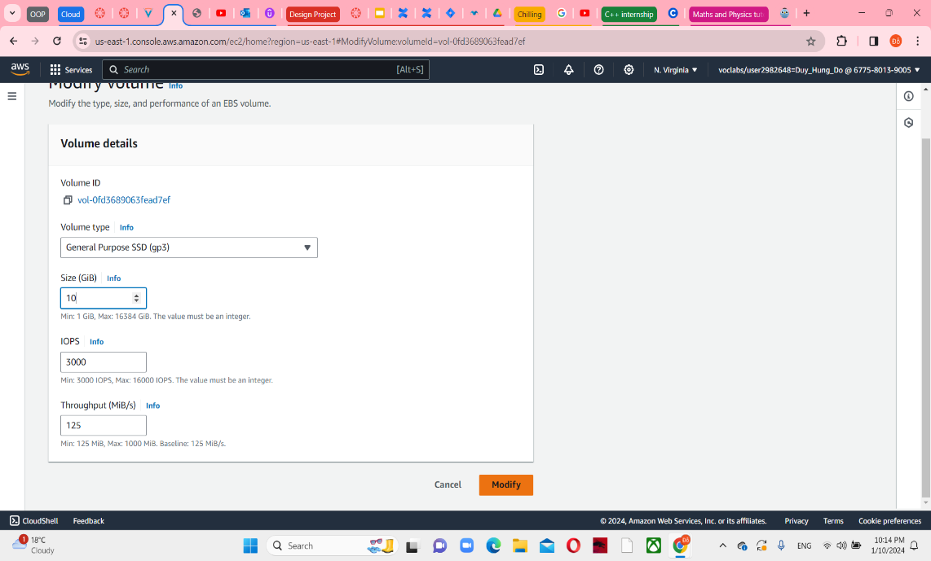

And then, Modify them by 2 steps

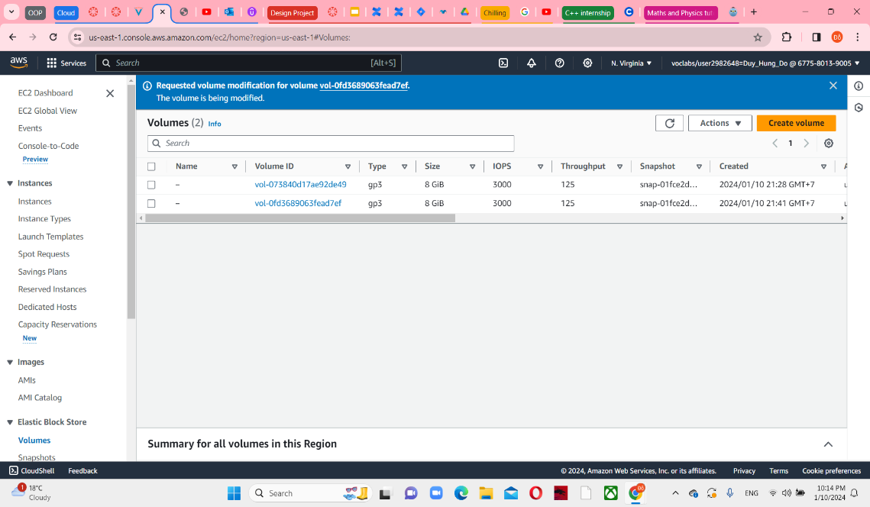

**Step 4: Start the Resized instances**

48, Return in the Web Server instance, select Start instance from Instance state menu.

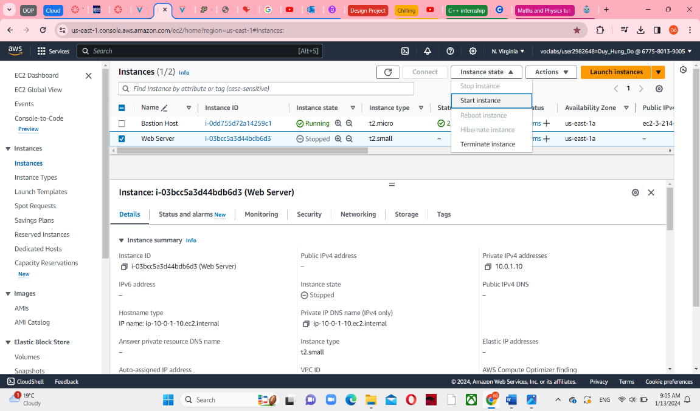

Wait until the successfully message appeared

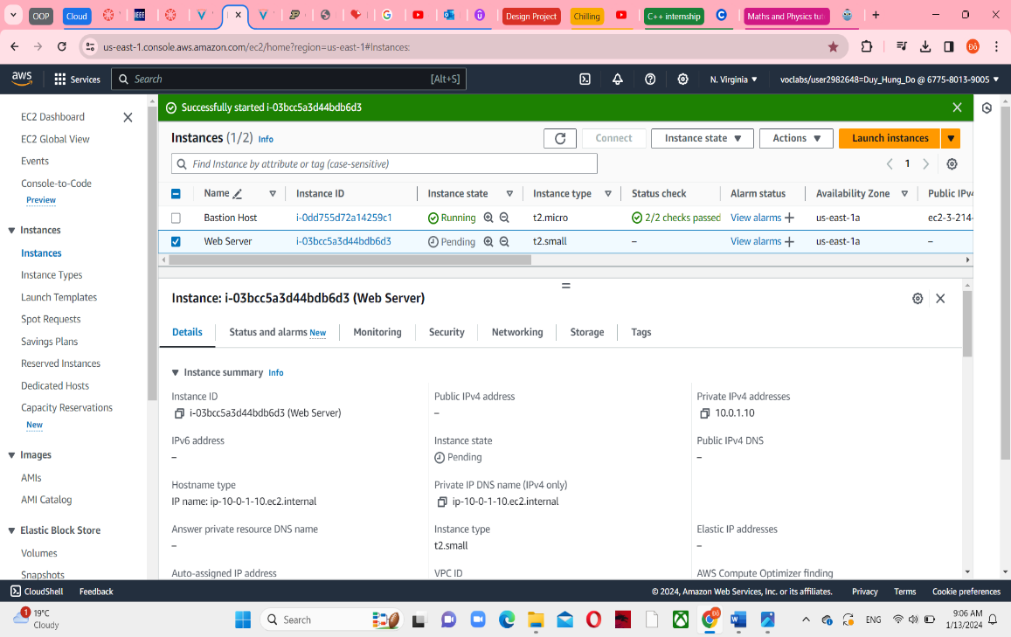

**Task 5: Explore EC2 Limits**

51, Search “Service Quotas” in the search box next to Services in the top left.

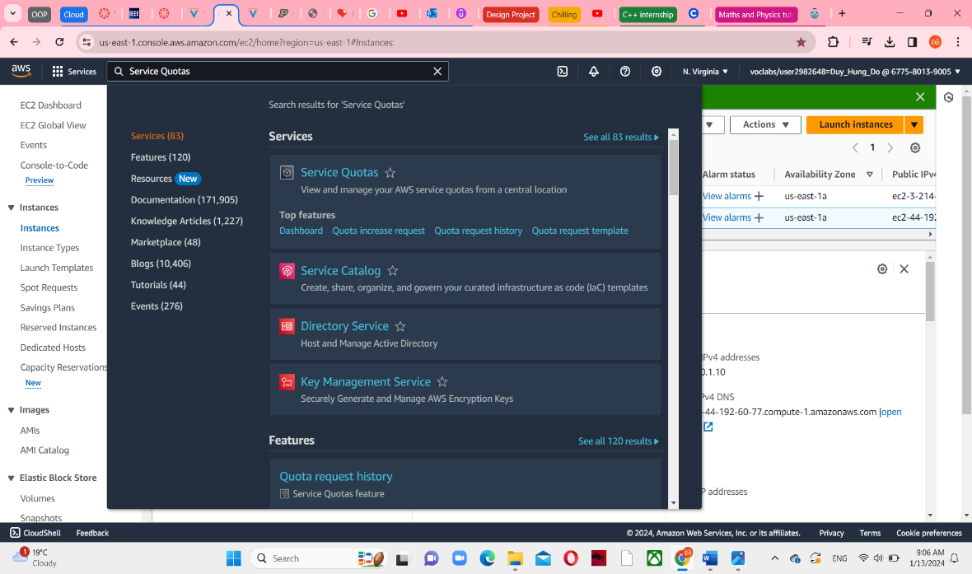

52, Choose AWS services from the left navigation menu

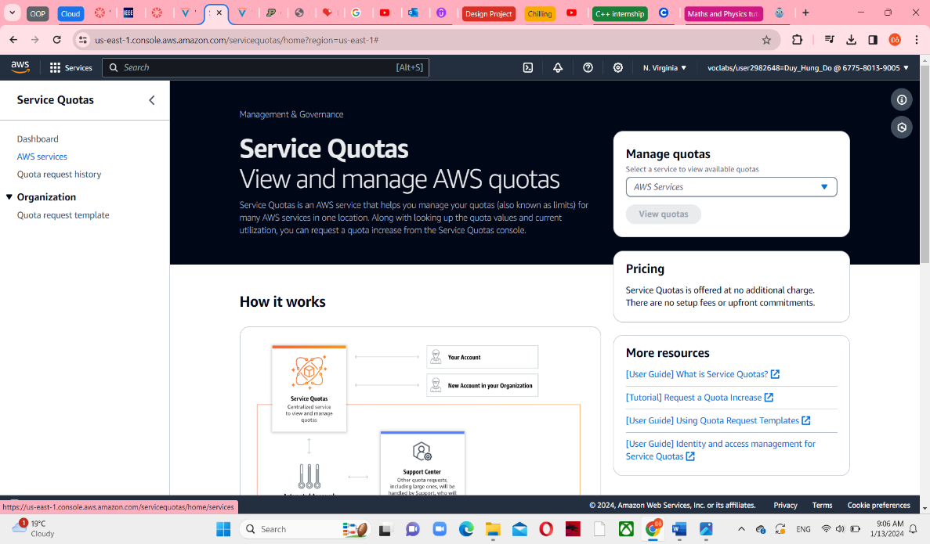

search for ec2 in Find services => choose Elastic Compute Cloud (Amazon EC2)

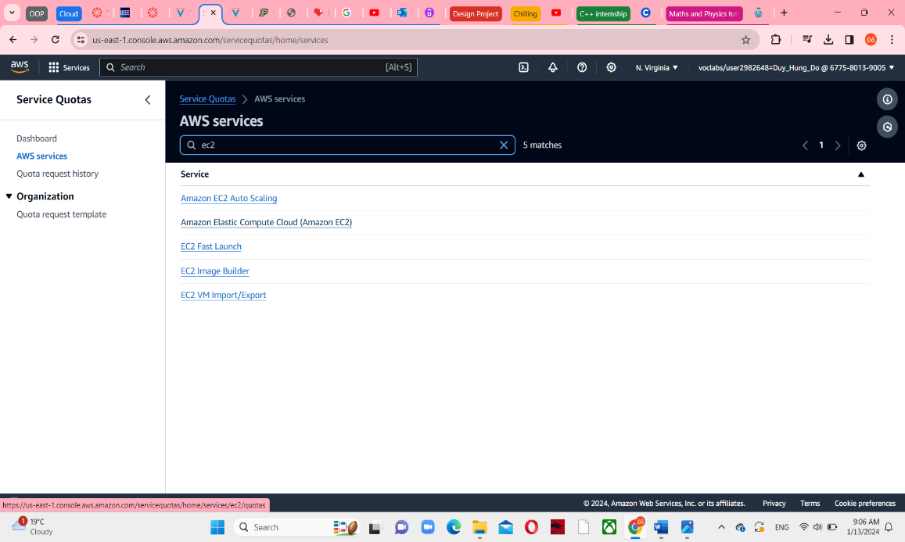

53, Search for running on-demand in Find quotas search bar

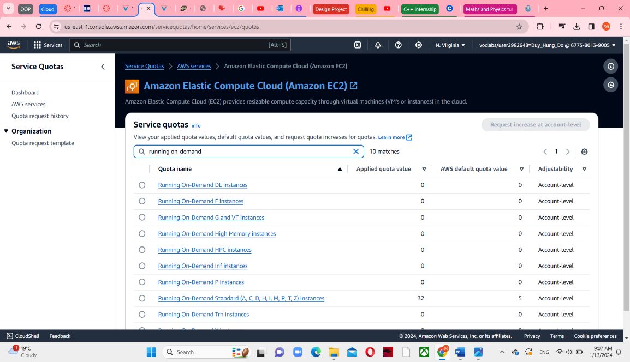

**Task 6: Test Stop Protection**

54, Return to EC2 Console web server, choose Instances in left navigation pane

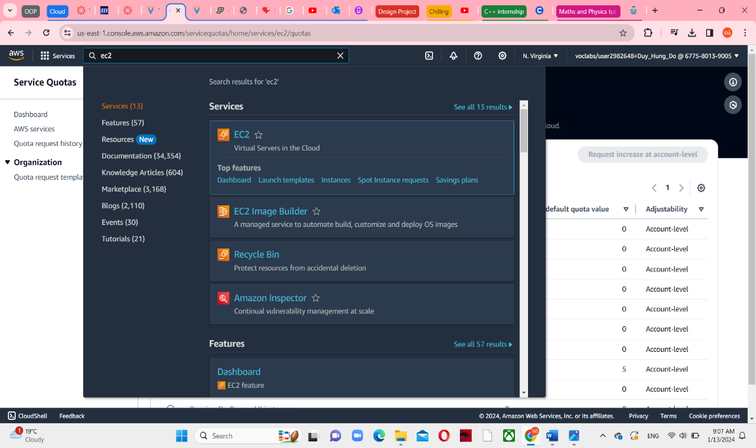

Select the Web Server and select Stop instance in Instance state menu

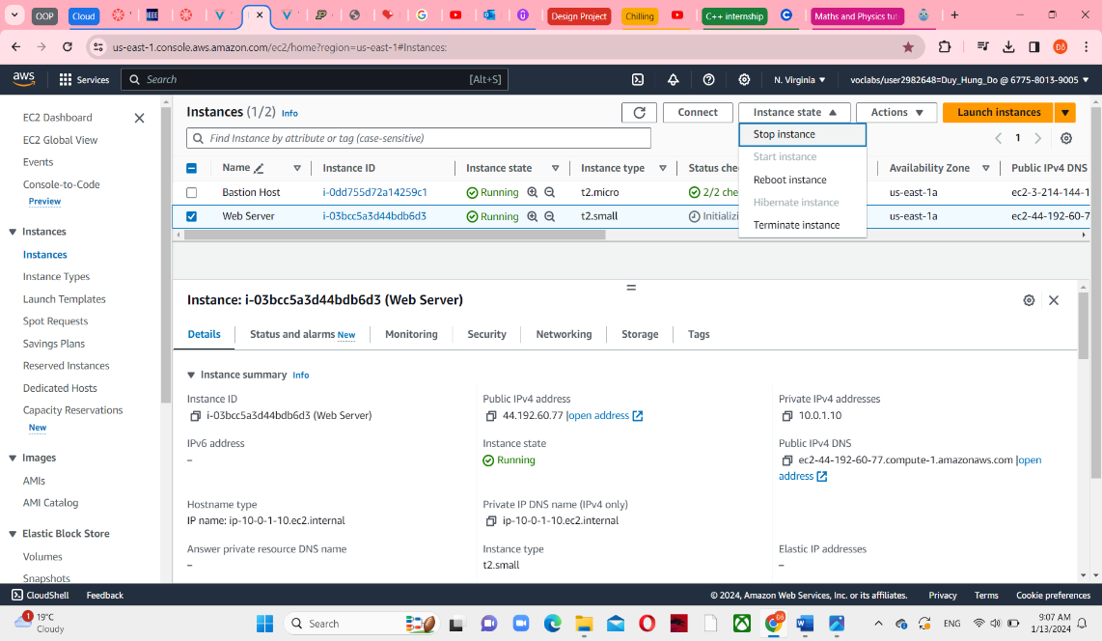

57, Choose Stop

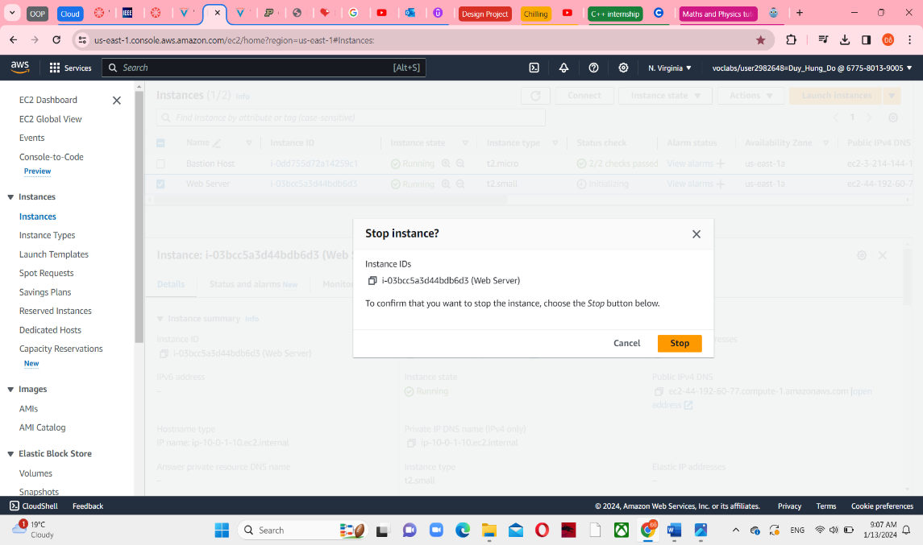

It is failed because you have enabled the stop protection.

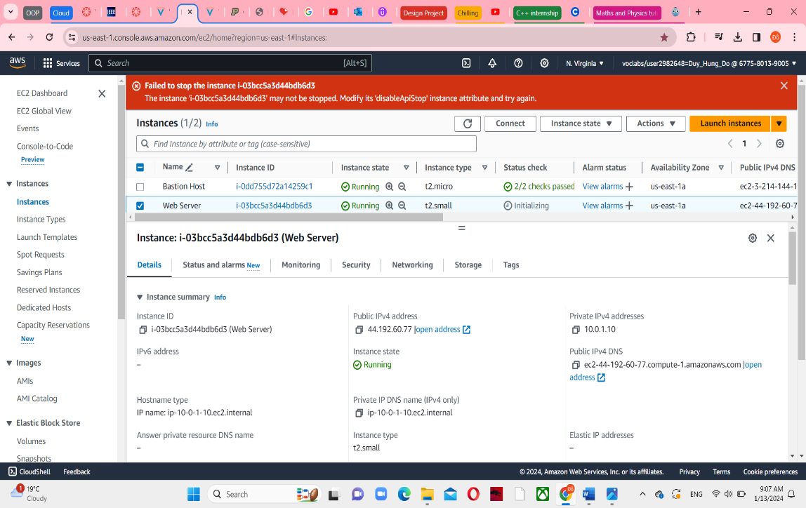

58, In the Action menu, select Instance settings -> Change stop protections

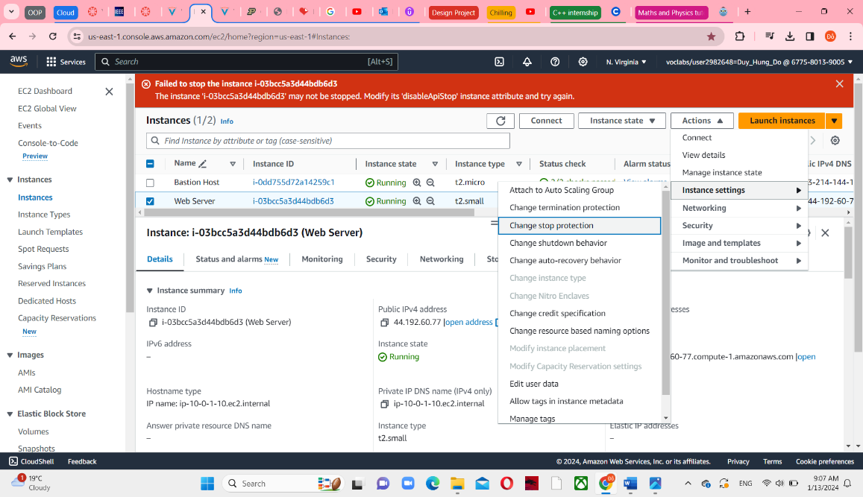

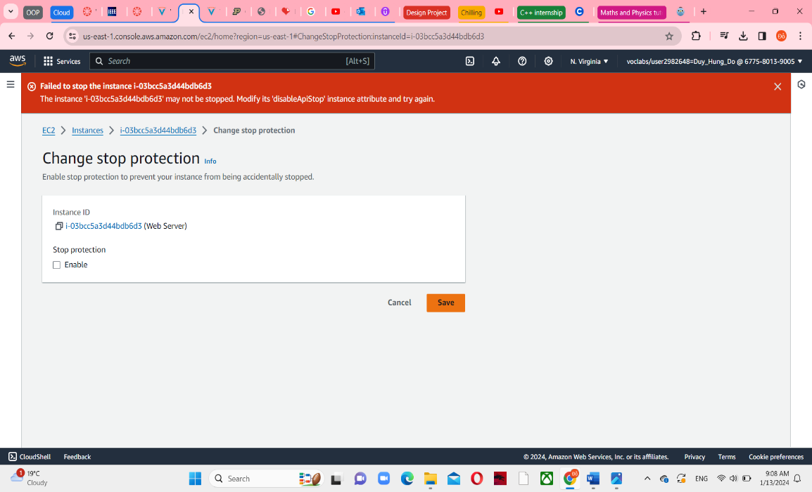

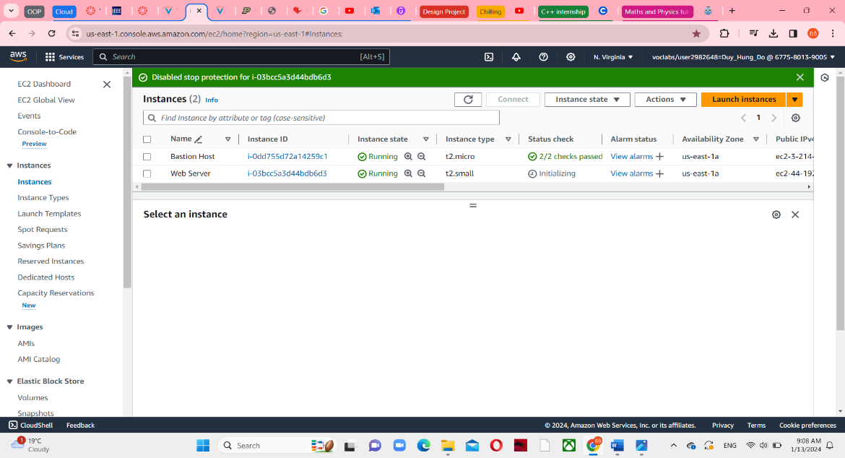

61, Select Stop instance again and choose Stop and you can see the message “Successfully stopped”

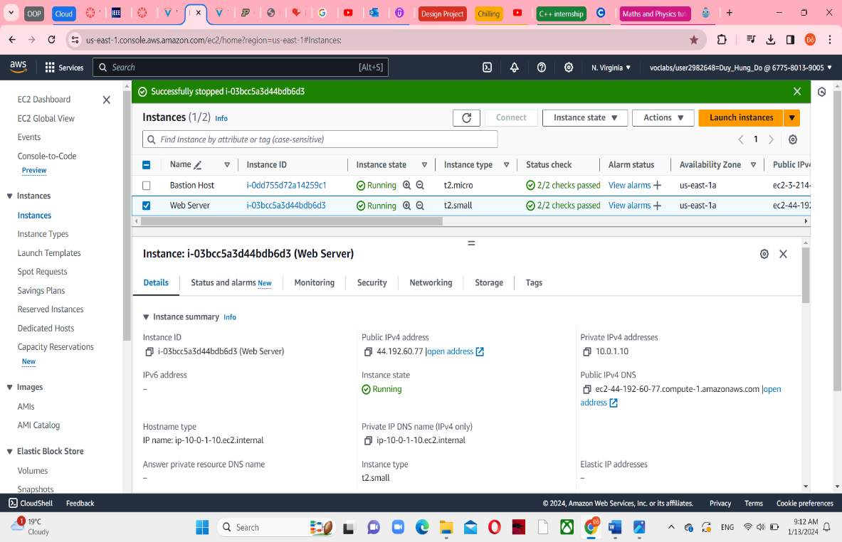

**Task 7: Submitting the work**

63, Return to vocareum page with the title, choose Submit at the top

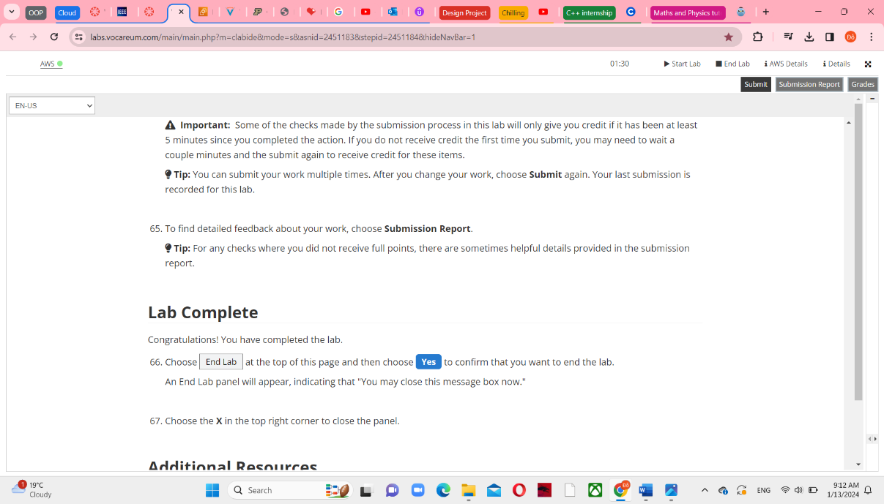

64, Choose Yes when promted, and after about 30s to 1m you can see Grades and Submission Report

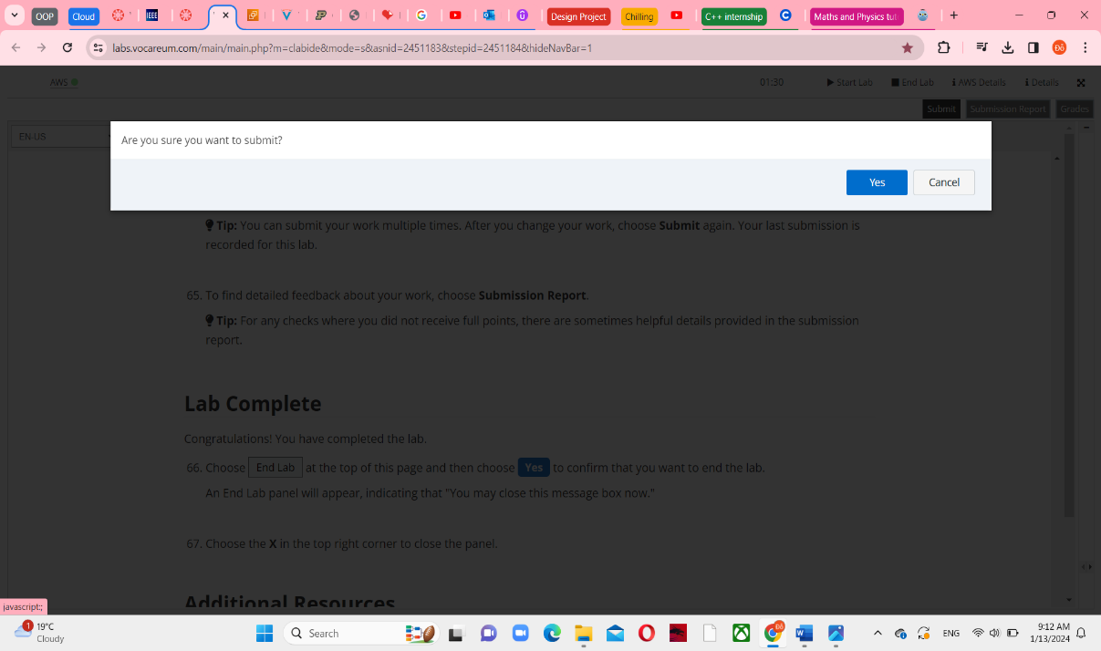

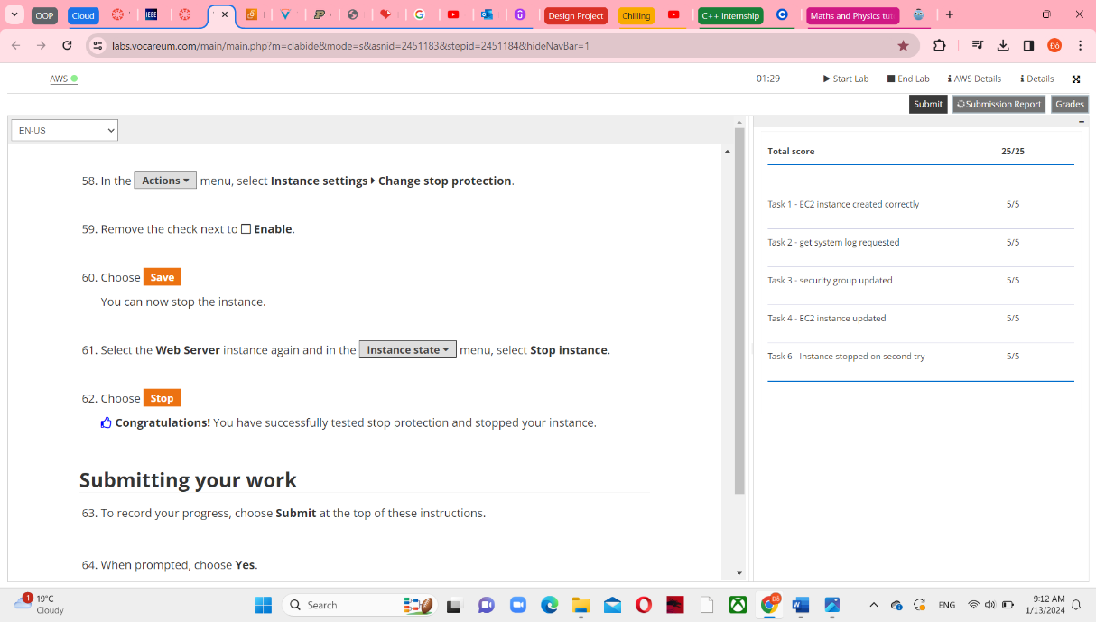

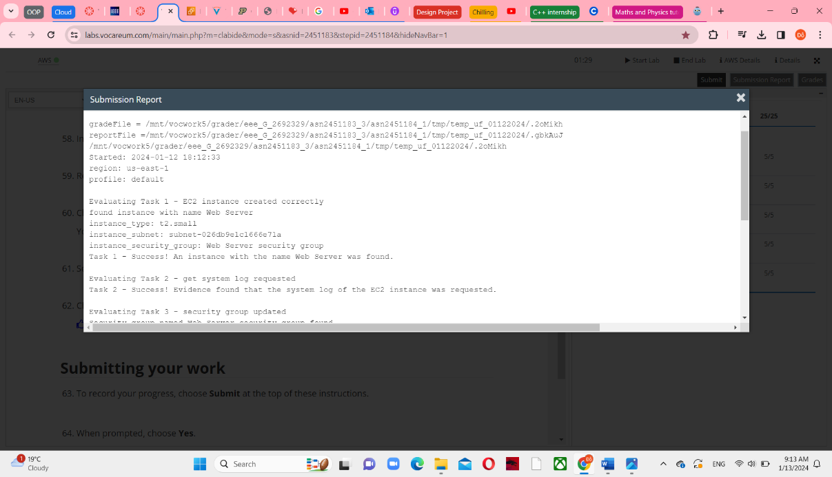

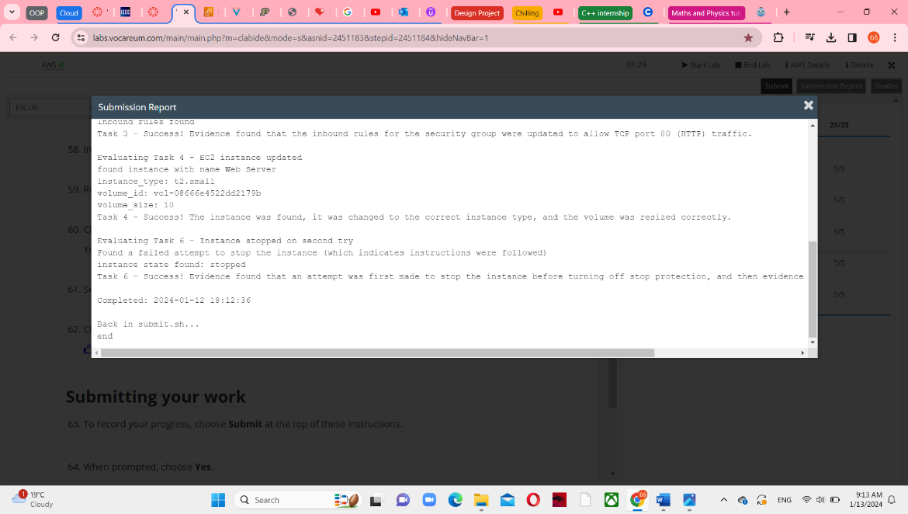

**Task 8: Lab Complete**

66, Choose End Lab at the top right and choose Yes to confirm that you want to end lab. This will be done and automatically save your points in aws instructure,

